Prelab 7 and 8

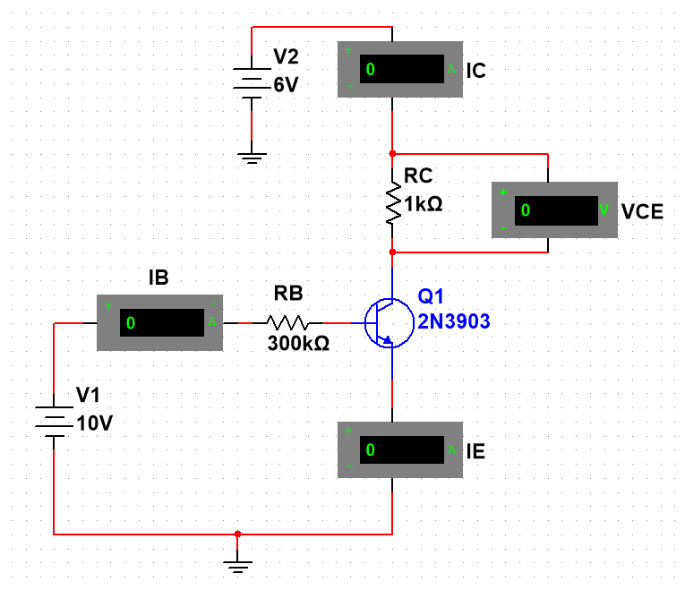

Circuit 7.1 Common Collector Circuit in Multisim

|  |  |  |  |  |  |  |
| --- | --- | --- | --- | --- | --- | --- |
| V1 (V) | V2 (V) | IB (mA) | IC (mA) | IE (mA) | VCE (V) | β |
| 4 | 0 | 0.012 | -0.01 | 0.00 | -0.01 | -0.661 |
| 4 | 0.5 | 0.011 | 0.379 | 0.39 | 0.379 | 34.455 |
| 4 | 1 | 0.011 | 0.701 | 0.712 | 0.701 | 63.727 |
| 4 | 1.5 | 0.011 | 0.707 | 0.718 | 0.706 | 64.273 |
| 4 | 2 | 0.011 | 0.711 | 0.722 | 0.711 | 64.636 |
| 4 | 2.5 | 0.011 | 0.716 | 0.727 | 0.716 | 65.091 |
| 4 | 3 | 0.011 | 0.721 | 0.732 | 0.721 | 65.545 |
| 4 | 3.5 | 0.011 | 0.725 | 0.736 | 0.725 | 65.909 |
| 4 | 4 | 0.011 | 0.73 | 0.741 | 0.73 | 66.364 |
| 6 | 0 | 0.018 | -0.011 | 0.01 | -0.011 | -0.611 |
| 6 | 0.5 | 0.018 | 0.399 | 0.417 | 0.399 | 22.167 |
| 6 | 1 | 0.018 | 0.857 | 0.874 | 0.856 | 47.611 |
| 6 | 1.5 | 0.017 | 1.195 | 1.212 | 1.194 | 70.294 |
| 6 | 2 | 0.017 | 1.203 | 1.221 | 1.203 | 70.765 |
| 6 | 2.5 | 0.017 | 1.211 | 1.229 | 1.211 | 71.235 |
| 6 | 3 | 0.017 | 1.219 | 1.237 | 1.219 | 71.706 |
| 6 | 3.5 | 0.017 | 1.227 | 1.245 | 1.227 | 72.176 |
| 6 | 4 | 0.017 | 1.235 | 1.253 | 1.235 | 72.647 |
| 8 | 0 | 0.025 | -0.012 | 0.012 | -0.012 | -0.480 |
| 8 | 0.5 | 0.025 | 0.41 | 0.434 | 0.41 | 16.400 |
| 8 | 1 | 0.025 | 0.878 | 0.903 | 0.878 | 35.120 |
| 8 | 1.5 | 0.024 | 1.345 | 1.369 | 1.345 | 56.042 |
| 8 | 2 | 0.024 | 1.709 | 1.733 | 1.708 | 71.208 |
| 8 | 2.5 | 0.024 | 1.722 | 1.746 | 1.722 | 71.750 |
| 8 | 3 | 0.024 | 1.734 | 1.758 | 1.734 | 72.250 |
| 8 | 3.5 | 0.024 | 1.745 | 1.769 | 1.745 | 72.708 |
| 8 | 4 | 0.024 | 1.756 | 1.781 | 1.756 | 73.167 |
| 8 | 4.5 | 0.024 | 1.767 | 1.792 | 1.768 | 73.625 |
| 8 | 5 | 0.024 | 1.779 | 1.804 | 1.779 | 74.125 |
| 10 | 0 | 0.032 | -0.014 | 0.018 | -0.014 | -0.438 |
| 10 | 0.5 | 0.032 | 0.417 | 0.448 | 0.417 | 13.031 |
| 10 | 1 | 0.032 | 0.89 | 0.921 | 0.89 | 27.813 |
| 10 | 1.5 | 0.032 | 1.367 | 1.398 | 1.367 | 42.719 |
| 10 | 2 | 0.032 | 1.838 | 1.867 | 1.838 | 57.438 |
| 10 | 2.5 | 0.032 | 2.232 | 2.263 | 2.231 | 69.750 |
| 10 | 3 | 0.032 | 2.254 | 2.285 | 2.254 | 70.438 |
| 10 | 3.5 | 0.032 | 2.269 | 2.3 | 2.269 | 70.906 |
| 10 | 4 | 0.032 | 2.284 | 2.315 | 2.283 | 71.375 |
| 10 | 4.5 | 0.032 | 2.299 | 2.329 | 2.298 | 71.844 |
| 10 | 5 | 0.032 | 2.313 | 2.344 | 2.313 | 72.281 |
| 10 | 5.5 | 0.032 | 2.328 | 2.359 | 2.328 | 72.750 |
| 10 | 6 | 0.032 | 2.342 | 2.374 | 2.342 | 73.188 |

Table 7.1 Multisim calculations

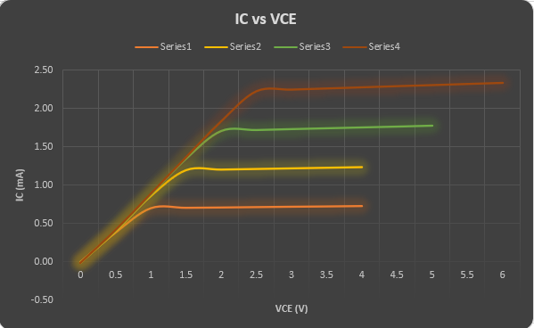

Graph 7.1 IC vs VCE

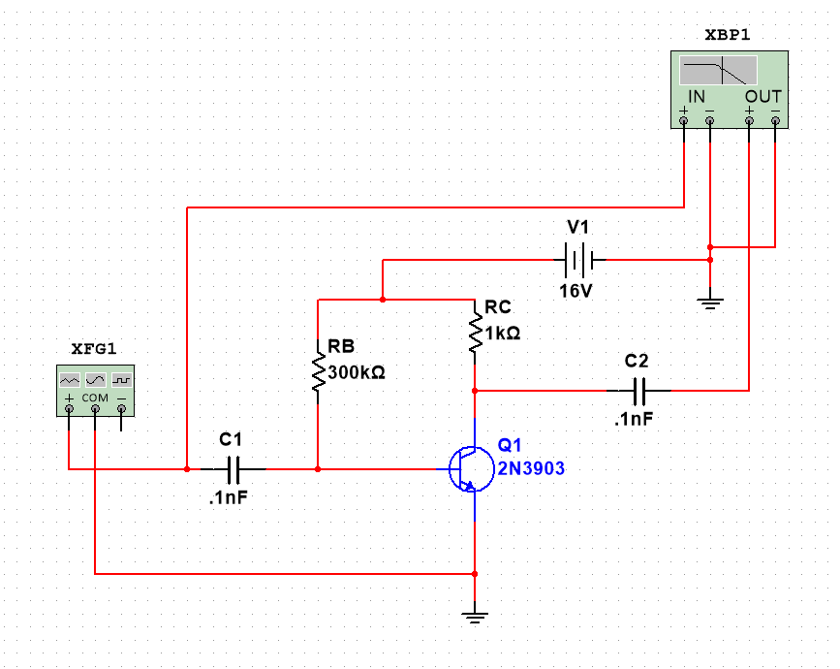

Figure 8.1 Common Collector Circuit in Multisim

|  |  |  |  |
| --- | --- | --- | --- |
| Frequency (Hz) | Vin (mV) | Vout (mV) | Gain (dB) |
| 10 | 500 | 0.00014059 | -65 |
| 30 | 500 | 0.00042285 | -55.435 |
| 60 | 500 | 0.00084701 | -49.401 |
| 100 | 500 | 0.00140068 | -45.032 |
| 200 | 500 | 0.00280505 | -39 |
| 500 | 500 | 0.00697333 | -31.09 |
| 1000 | 500 | 0.01405853 | -25 |
| 2000 | 500 | 0.02865101 | -18.816 |
| 5000 | 500 | 0.06950883 | -11.118 |
| 10000 | 500 | 0.14058533 | -5 |
| 15000 | 500 | 0.21425946 | -1.34 |
| 20000 | 500 | 0.28555516 | 1.155 |
| 50000 | 500 | 0.70801101 | 9.042 |
| 75000 | 500 | 1.06032746 | 12.55 |
| 100000 | 500 | 1.40585331 | 15 |
| 150000 | 500 | 2.08660387 | 18.43 |
| 200000 | 500 | 2.73268774 | 20.773 |
| 500000 | 500 | 5.71531286 | 27.182 |
| 750000 | 500 | 7.16291848 | 29.143 |
| 1000000 | 500 | 8.0000004 | 30.103 |
| 1500000 | 500 | 8.8204351 | 30.951 |
| 2000000 | 500 | 9.17043651 | 31.289 |

Table 8.1 VIN, VOUT, Gain according to frequency

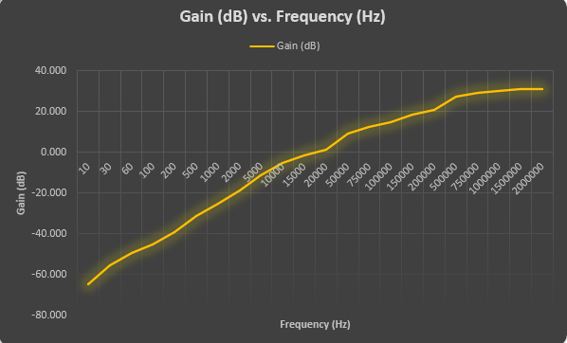

Table 8.1 Gain vs Frequency